[GoldenRule]

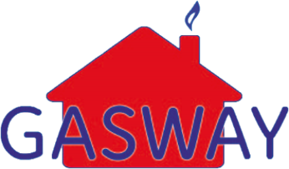18 Burnet Road

Sweet Briar Industrial Estate

Norwich, NR3 2BS

[Tel: 0800 074 3030](Tel:01603309590)

Email: [enquiries@gasway.co.uk](mailto:enquiries@gasway.co.uk)

|  |
| --- |
| footer.jpg  Head Office: Gasway Services Ltd – 18 Burnet Road – Sweet Briar Industrial Estate – Norwich – NR3 2BS  Telephone; 0800 0743030 Email: enquiries@gasway.co.uk  Company No: 4158628  VAT No: 688 4634 78 |

**[theDate]**

[Name]

[Address1]

[Address2]

[Address3]

[Address4]

[Address5]

[Postcode]

Dear [Name]

**Re: Gasway Boiler Cover Plans**

Our records show that the previous owner protected their heating system with a Gasway Boiler Cover Plan. Their plan was cancelled when the property was sold.

We are a local company established over 30 years ago and we have over 70 experienced and fully qualified engineers ready to come to your rescue should your heating or hot water stop working.

We would like to take this opportunity to offer some help at what can be both stressful and expensive time by giving you **TWO MONTHS FREE COVER** when you sign up for any of our plans.

Please see below for the key highlights of our Boiler Cover Plans:

* Guaranteed same day call out*
* No excess*
* Unlimited call outs*
* All parts and labour covered*
* Annual service included

Please see enclosed leaflet for an illustration of costs and a comparison of the levels of cover on offer. Prices start from £15.99 per month – so there is a level of cover for all budgets.

We offer a Direct Debit payment facility at no extra charge giving the advantage of spreading the cost of payment over twelve monthly easy instalments.

For further information or to take out one of these covers, then **please call 01603 309590.**

Yours sincerely

The Coverplan Team

* Terms and Conditions apply